ALB Ingress- Name based Virtual Host/ Host Header Routing:-
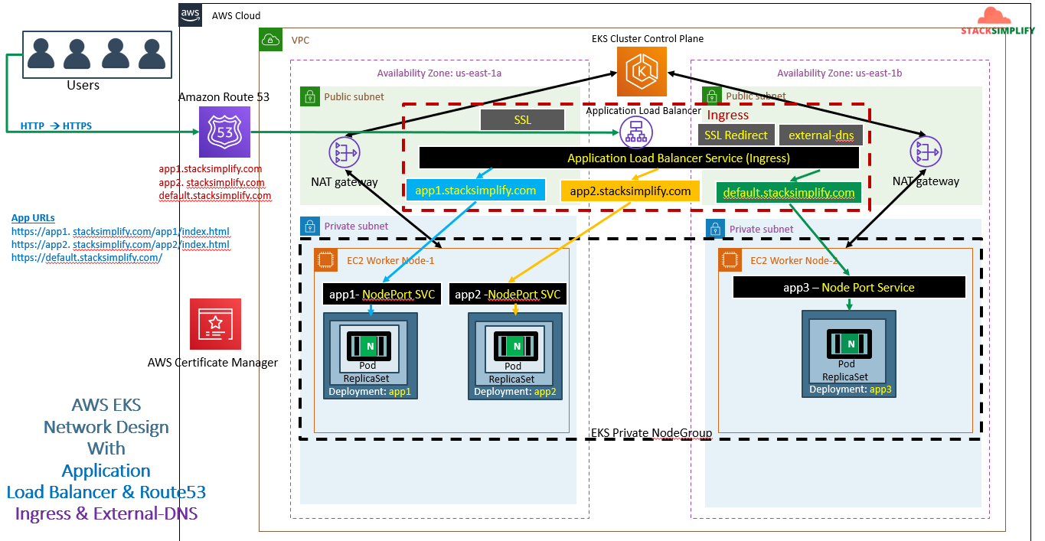
I name based Virtual host routing, if you search with app1.stacksimplify.com it will go to app1 POD through app1 NodePort service, if you search with app2.stacksimplify.com it will go to app2 POD through app2 NodePort service. if you search with default.stacksimplify.com it will go to app3 POD through app3 NodePort service
In previous session our manisfest starts with ‘http’ now it will start with ‘host’.
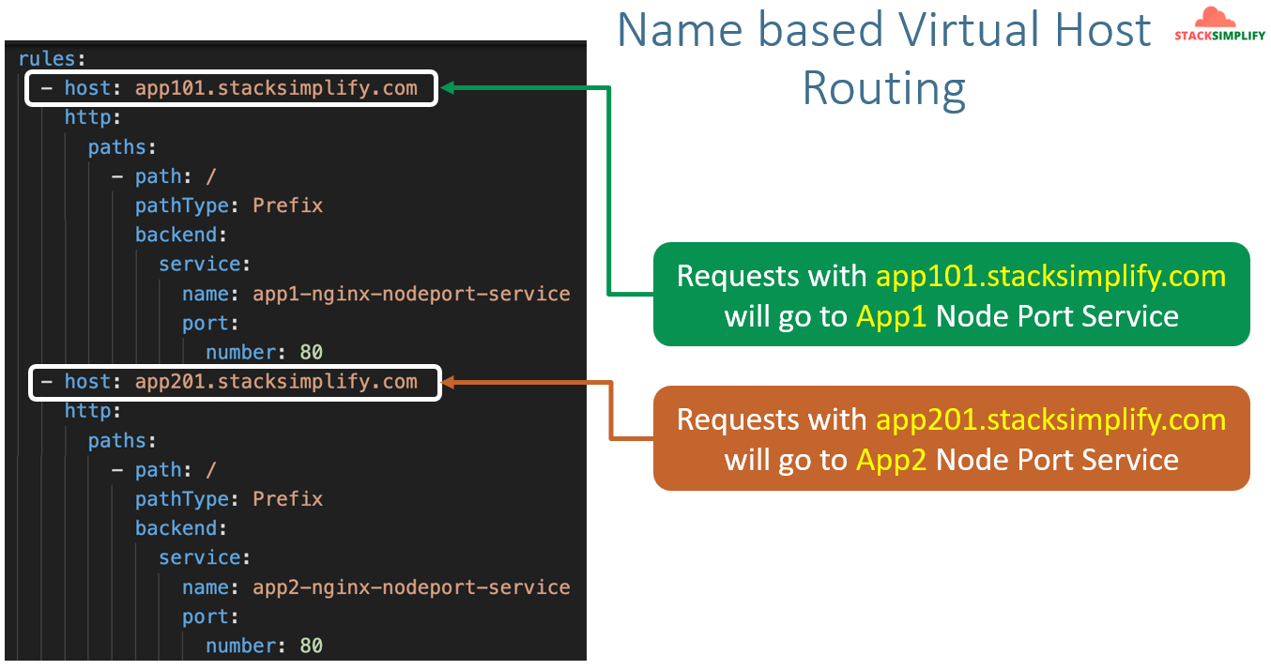
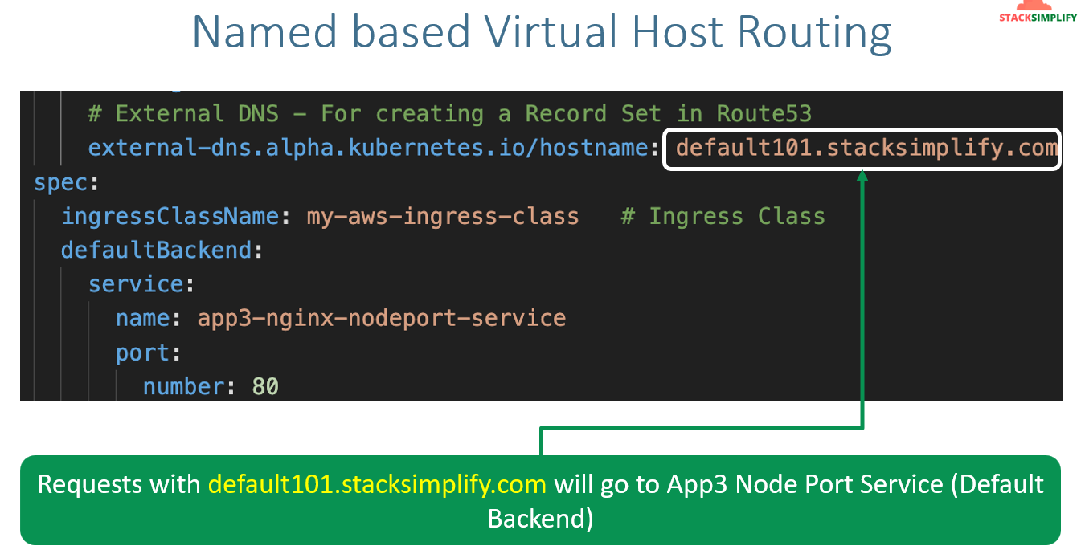
We are going to implement the name based virtual Host Routing. We are going to copy the deployment manifest files of 3 apps from previous session it will be same but for ingress we are going to make changes.
Update the ingress manifest like below:
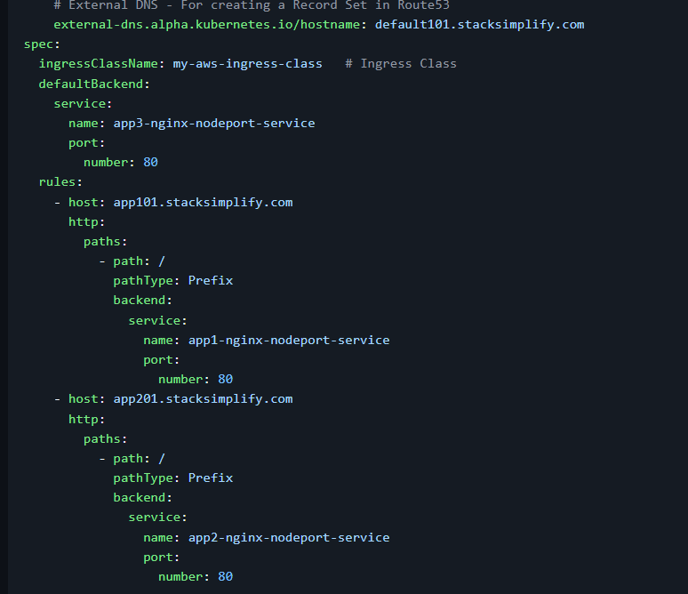
Then run apply command and verify the external DNS pod logs.
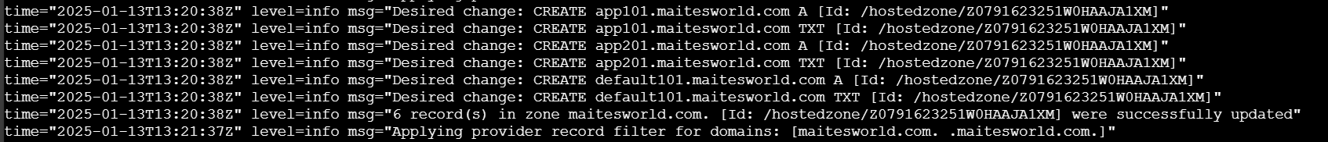
Now go and try to access the application you can access it.
Note:- While using Ingress external DNS the app was all the time down. Only few times was able to see the app as running state. But, while trying to access through ELB it was working fine. Need to check deeper into this.

